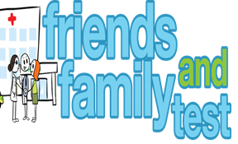
HAVE YOUR SAY TO IMPROVE YOUR CARE!
COMPLETE OUR SHORT QUESTIONNAIRE ON HOW LIKELY YOU ARE TO RECOMMEND OUR SURGERY TO FAMILY AND FRIENDS.
We have been collecting your replies and below are our results for June 26
Very Good | Good | Neither Good/nor poor | Poor | Very Poor | Don’t Know
38 | 3 | 1 | 0 | 1 | 1

Recent comments:
- Not a single negative thing to say!
- Good doctors I can get an appointment quickly.
- Great friendly service.
- Absolutely an amazing practice.
- This surgery is exceptional in every way.
- Always very helpful staff and doctors.

