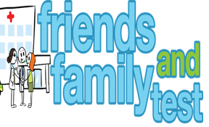
HAVE YOUR SAY TO IMPROVE YOUR CARE!
COMPLETE OUR SHORT QUESTIONNAIRE ON HOW LIKELY YOU ARE TO RECOMMEND OUR SURGERY TO FAMILY AND FRIENDS.
We have been collecting your replies and below are our results for
December 25
Very Good | Good | Neither Good/nor poor | Poor | Very Poor | Don’t Know
18 | 4 | 1 | 1 | 5 | 0

Recent comments:
- Excellent staff and always quick response when required.

- I am satisfied with everything at this doctor’s surgery.
- Great service all staff.
- Can always accommodate appointments for myself and my family.
- Best doctors around , make sure all patients are looked after.

