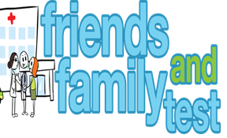
HAVE YOUR SAY TO IMPROVE YOUR CARE!
COMPLETE OUR SHORT QUESTIONNAIRE ON HOW LIKELY YOU ARE TO RECOMMEND OUR SURGERY TO FAMILY AND FRIENDS.
We have been collecting your replies and below are our results for November 25
Very Good | Good | Neither Good/nor poor | Poor | Very Poor | Don’t Know
17 | 2 | 0 | 0 | 1 | 0

Recent comments:
- They get the job done!
- Can always get an appointment.
- Staff are very helpful.
- A friendly waiting room.
- I feel confident and well looked after.
- The best doctors!

